**KWAME NKRUMAH UNIVERSITY OF SCIENCE AND TECHNOLOGY**

**DEPARTMENT OF MECHANICAL ENGINEERING**

**EQUATIONS, TABLES AND CHARTS**

**ME 373: MACHINE ELEMENT DESIGN I**

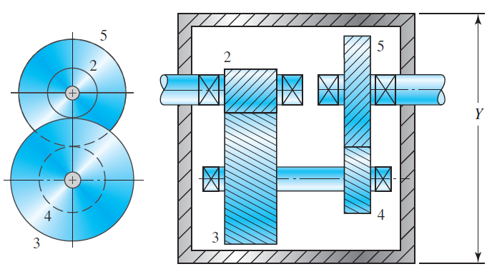

**Compiled By**

S. P. Owusu-Ofori

P. Y. Andoh

F. Nyarko

f. Davis

**Reference Textbook:**

Shigley’s Mechanical Engineering Design, 10th edition

By Richard Budynas, and J. Nisbett, McGraw Hill

DO NOT WRITE IN THE BOOK WITH PEN

***DESIGN FOR FATIGUE LOADS***

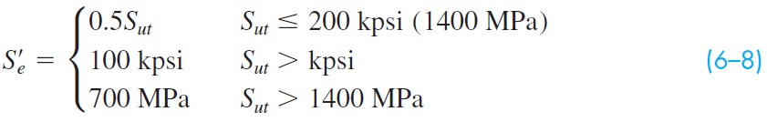

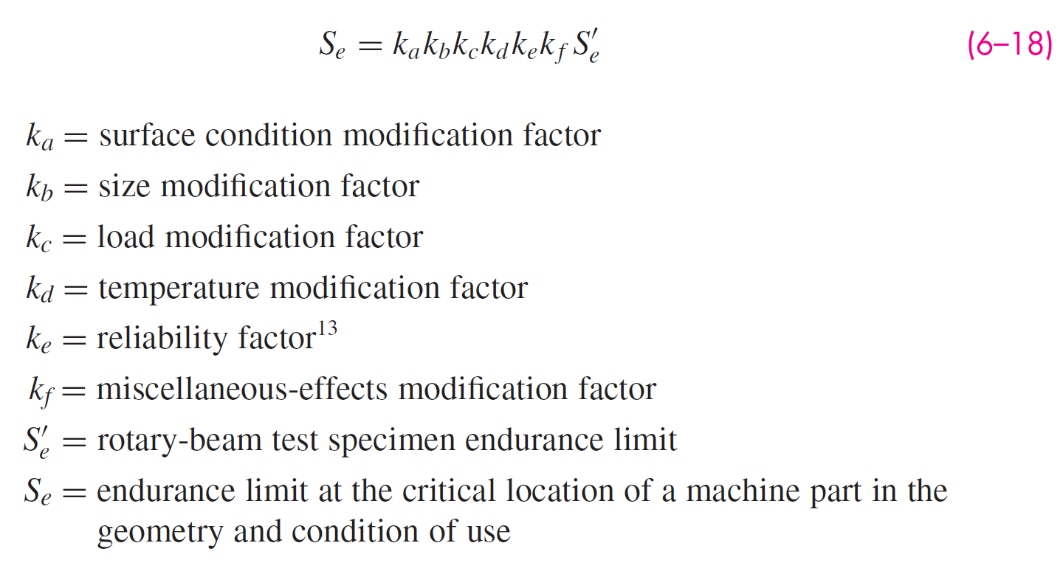

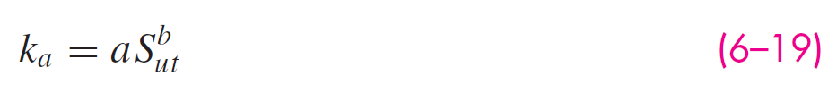

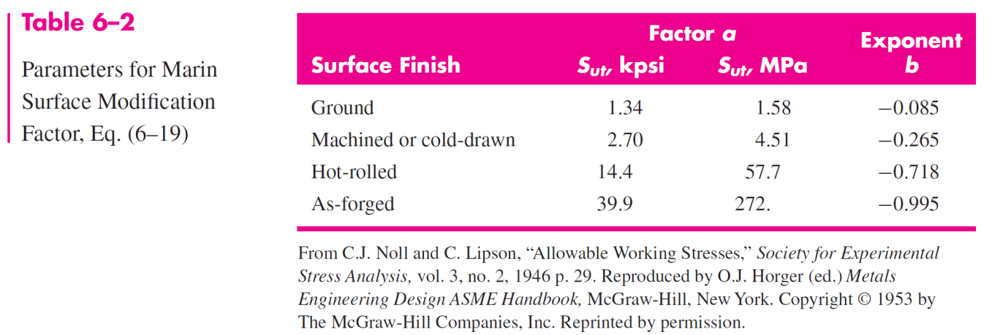

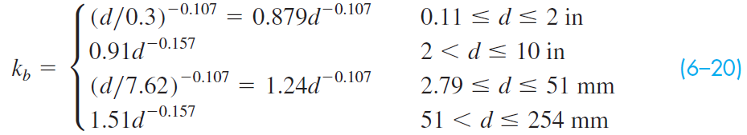

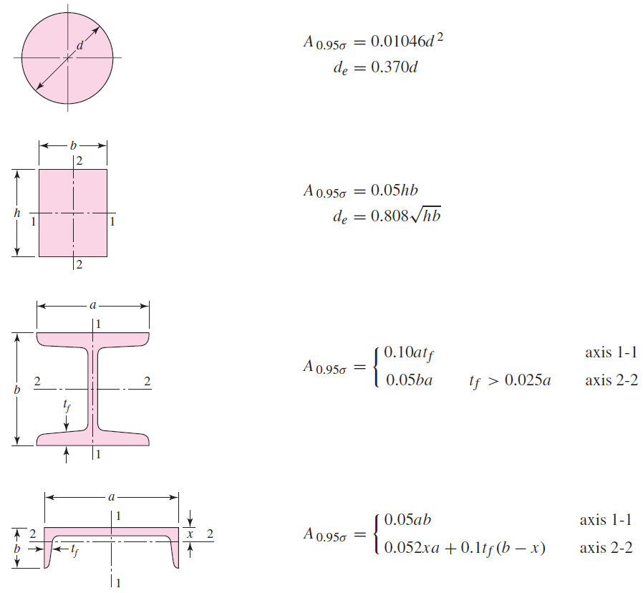



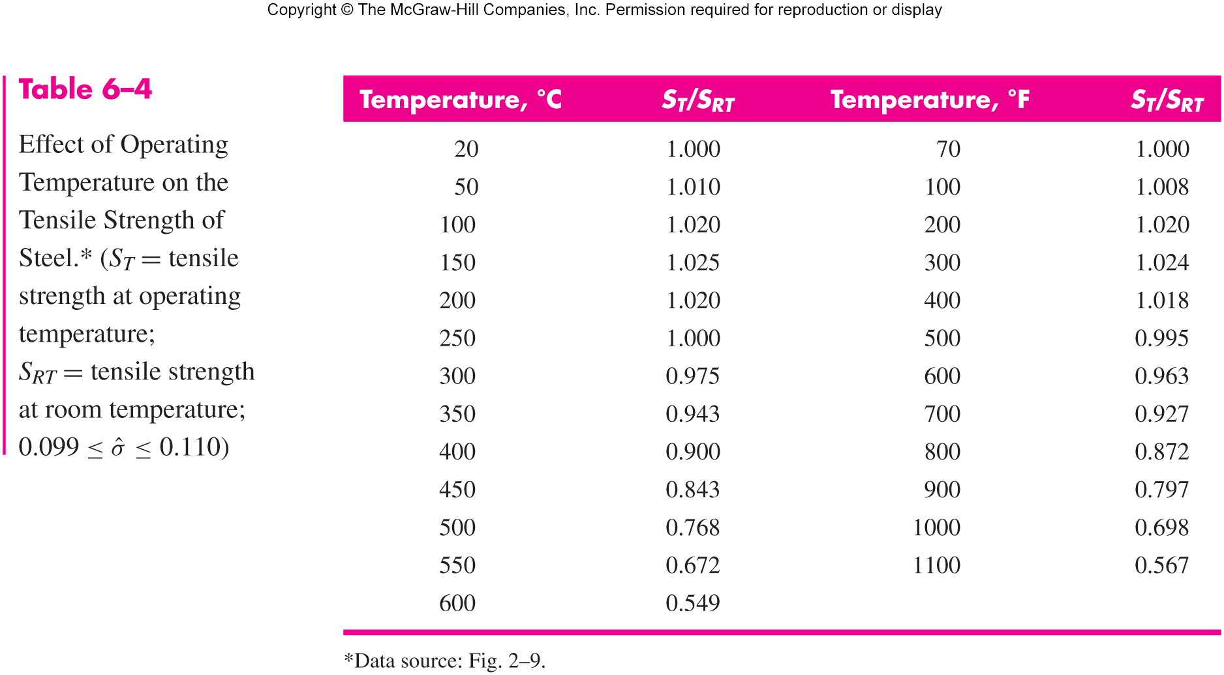

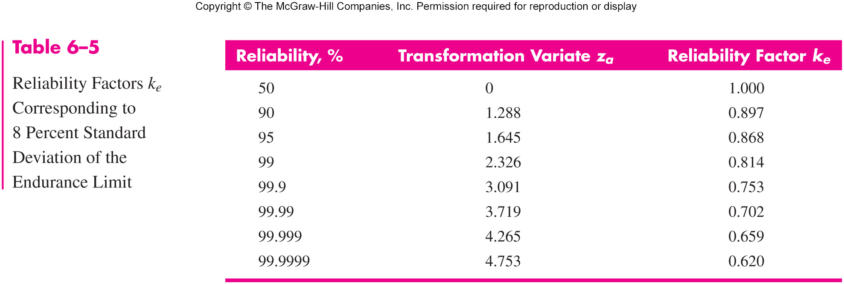

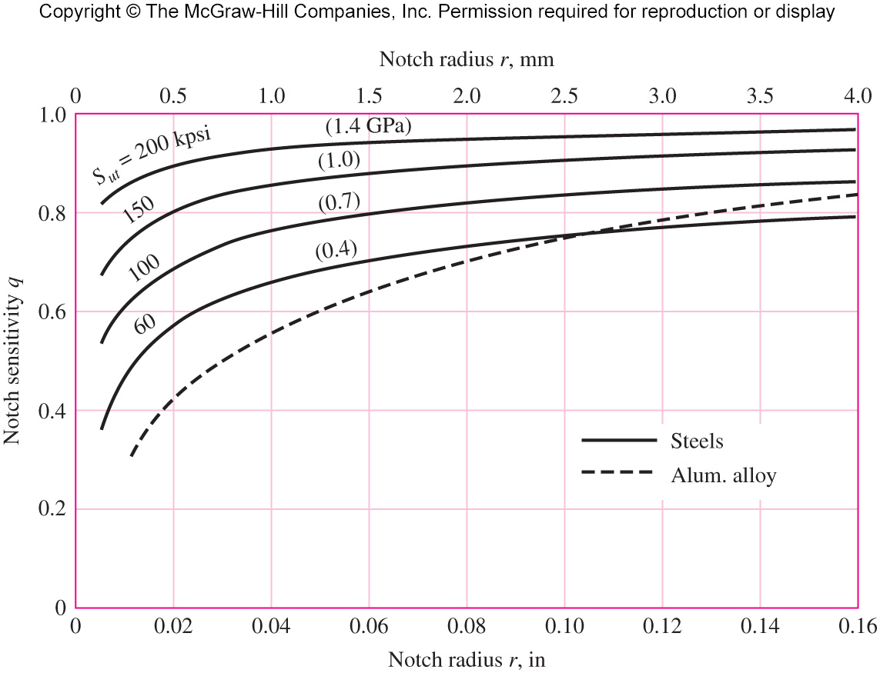

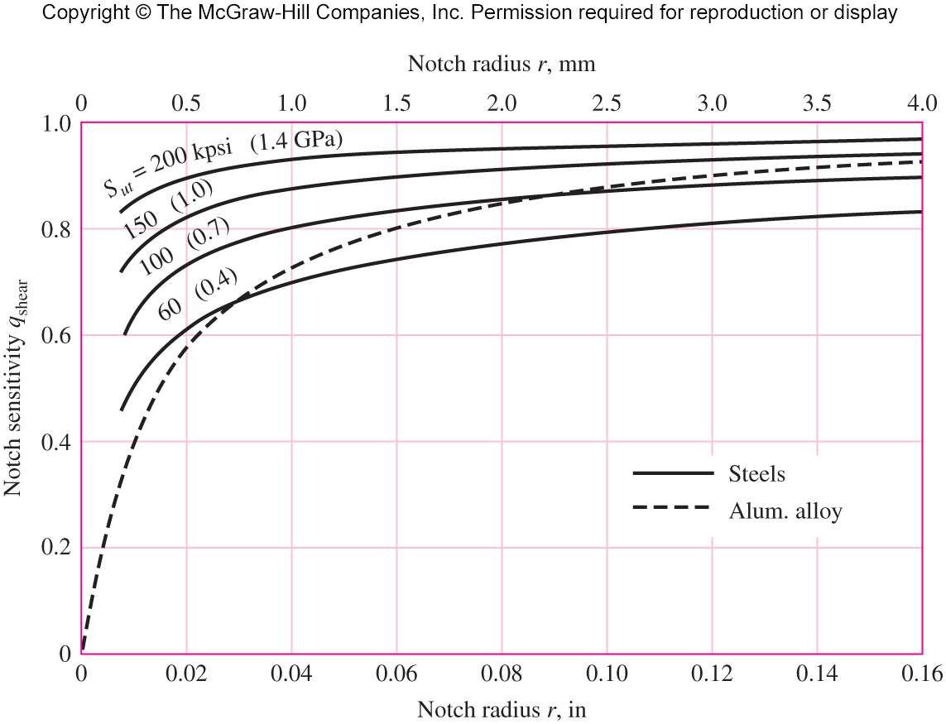

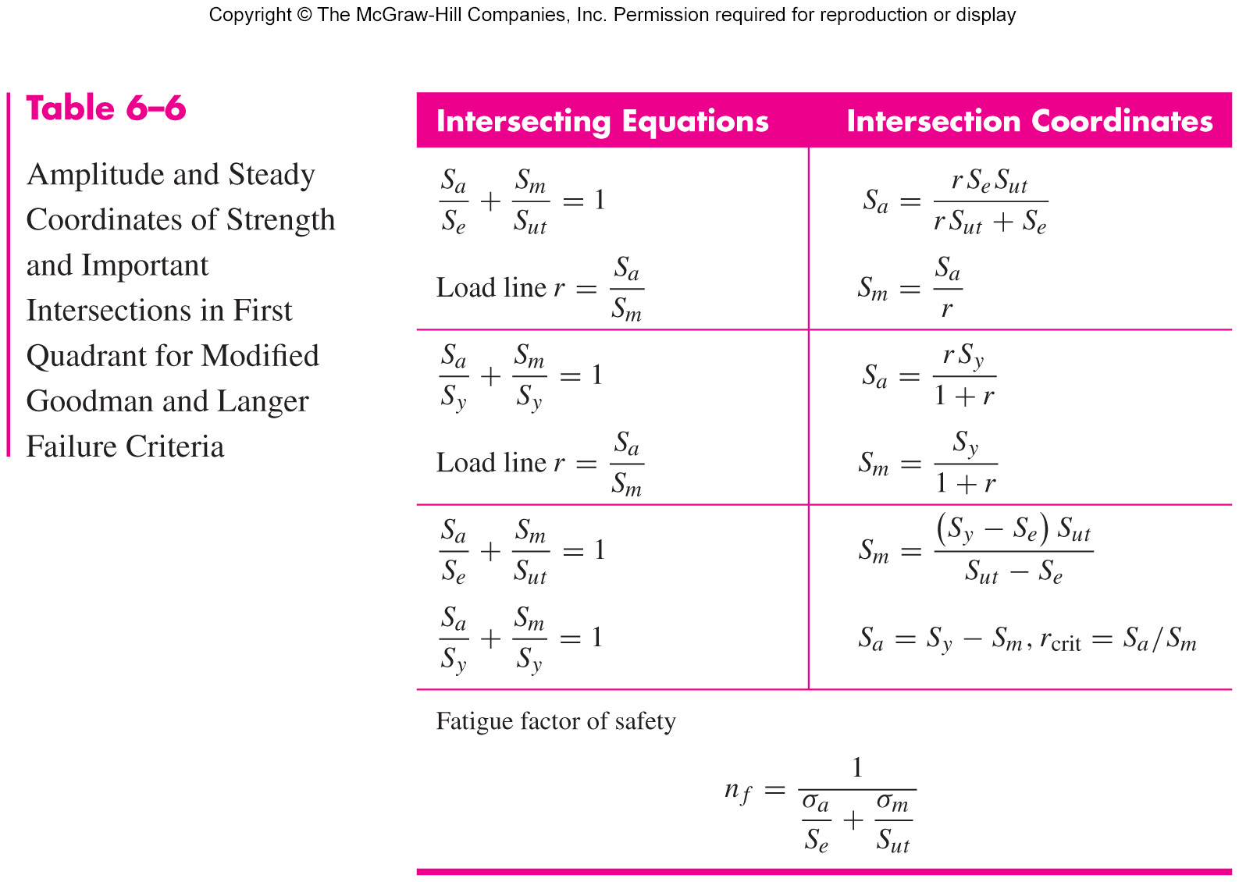

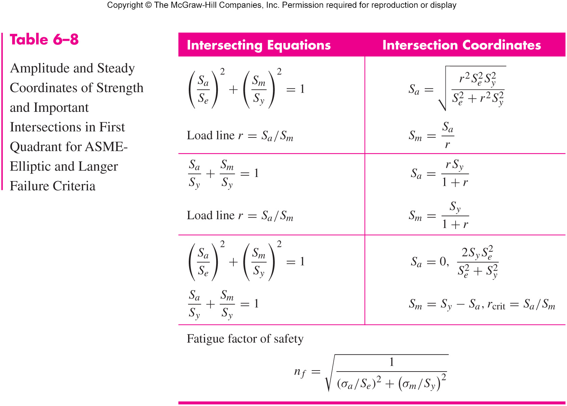

**LUBRICATION OF JOURNAL BEARINGS**



unjm





**ROLLING CONTACT (BALL) BEARINGS**



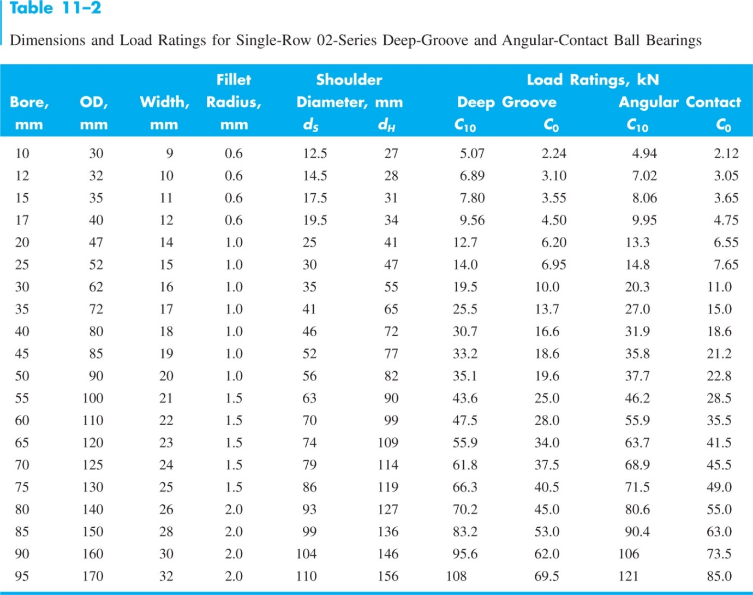

**HELICAL COMPRESSION SPRINGS**





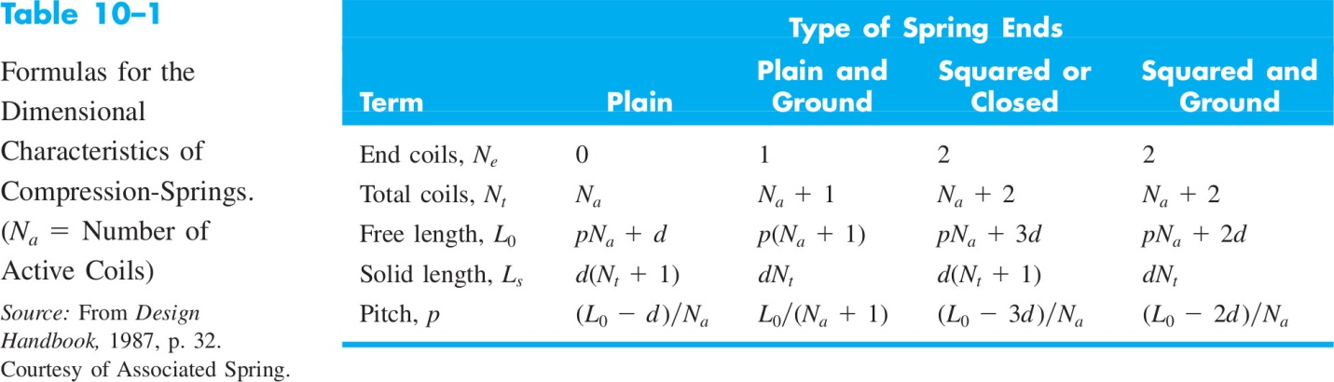

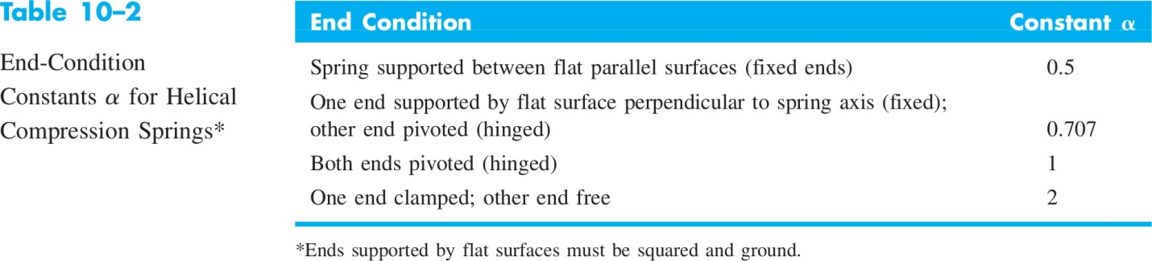



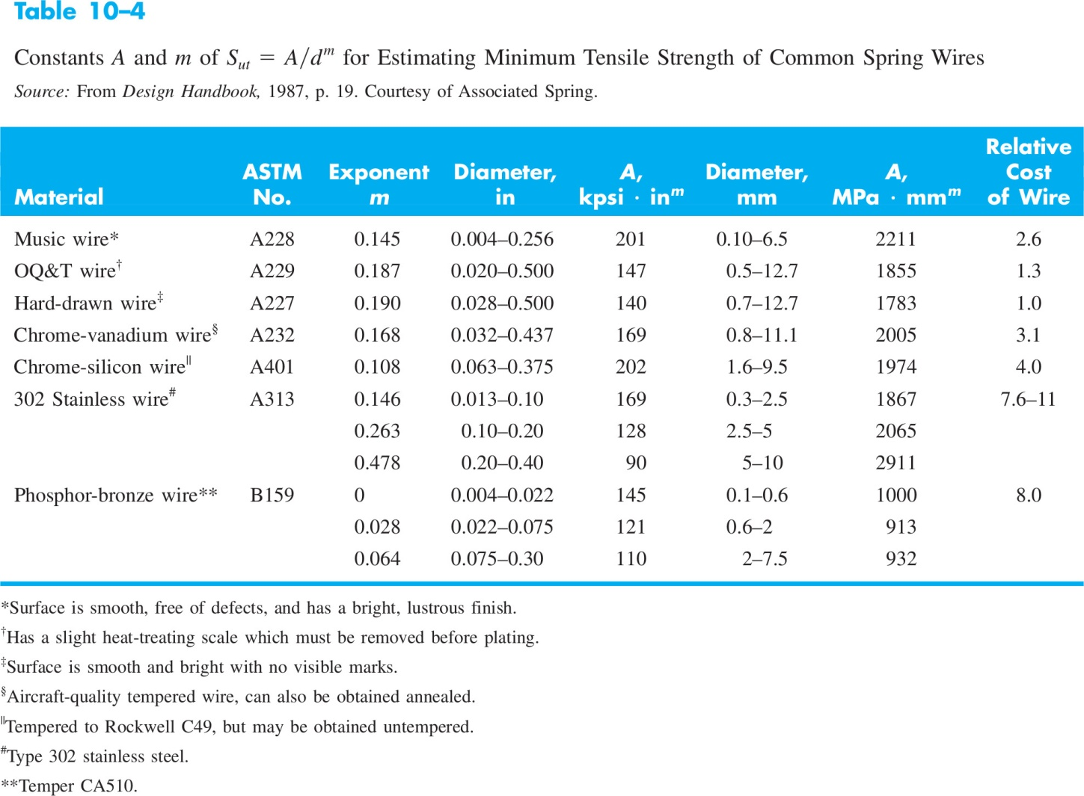



**BOLTS, SCREWS AND FASTENERS**





 



**POWER TRANSMISSION SHAFTS**

DE-ELIPTICAL MODEL





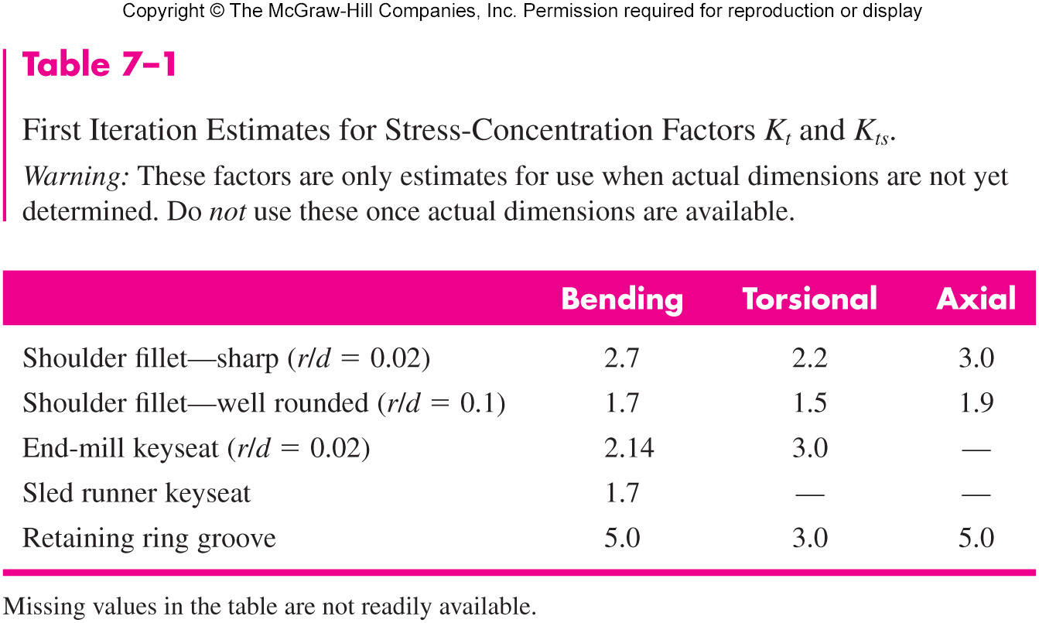

**STRESS CONCENTRATION FACTORS**

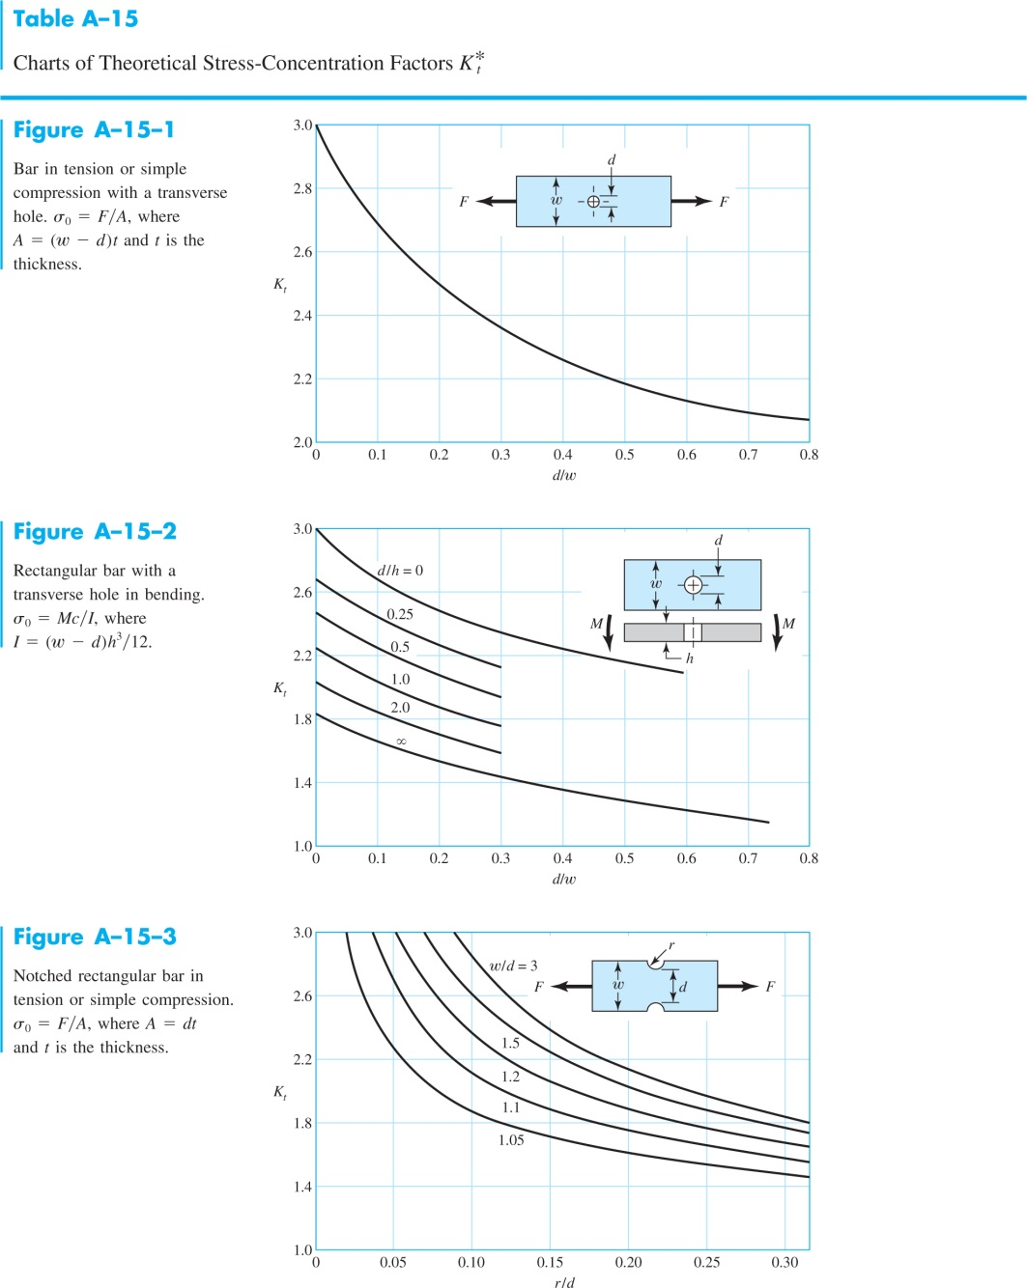

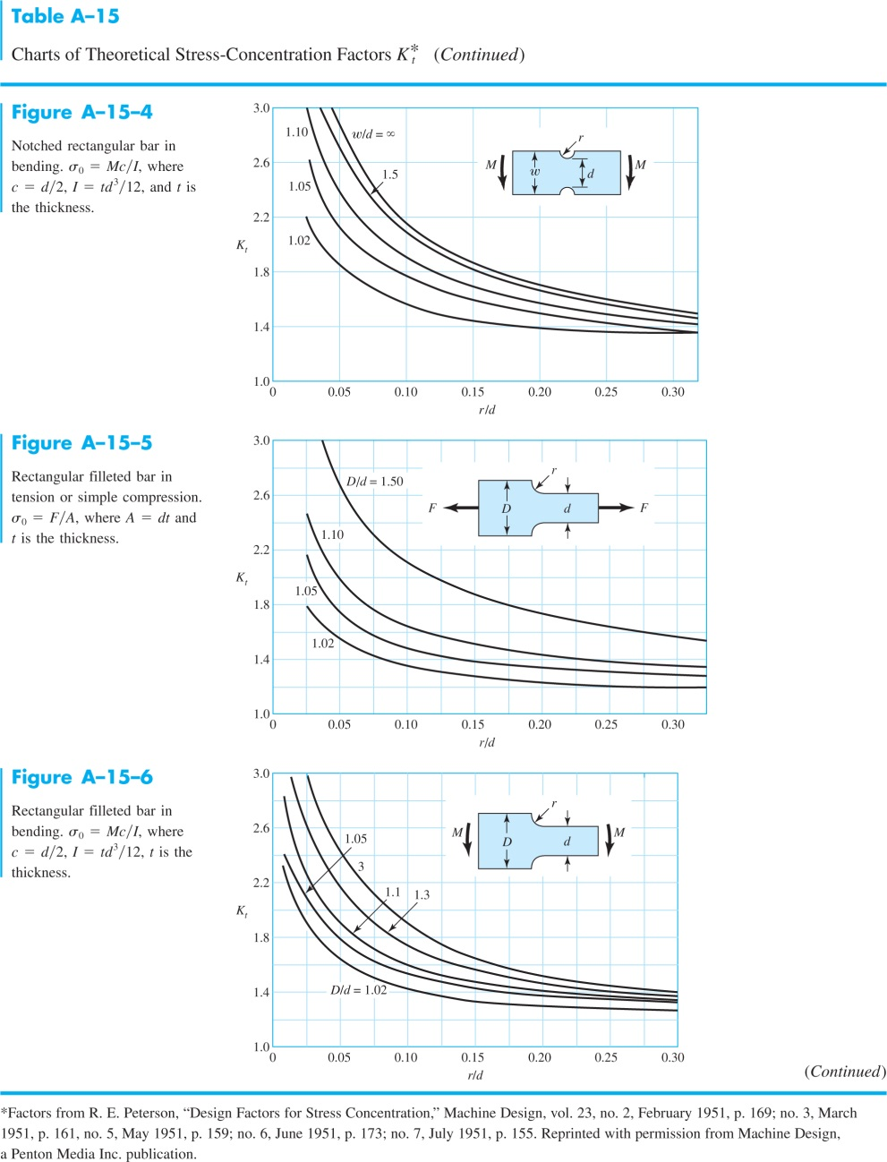

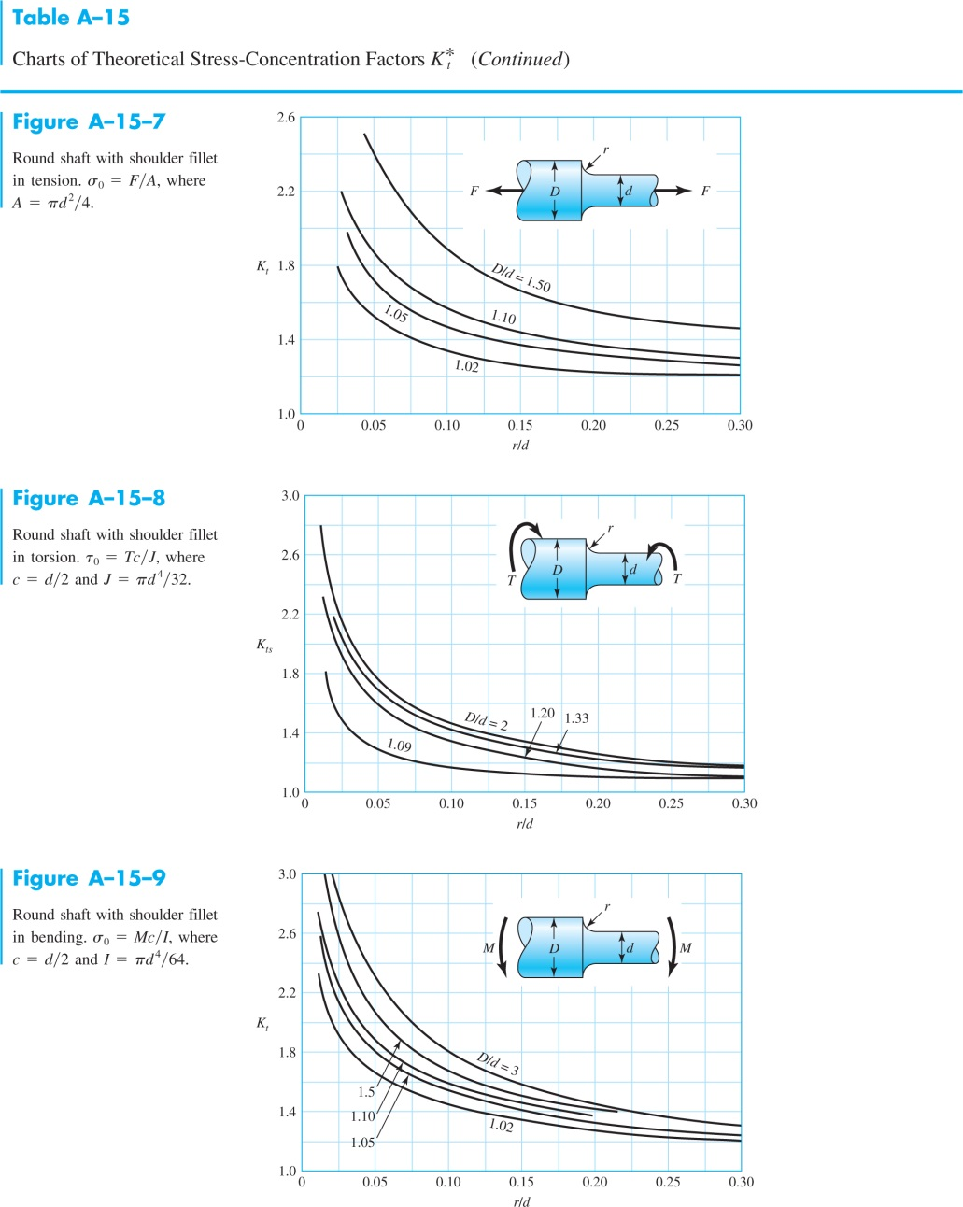

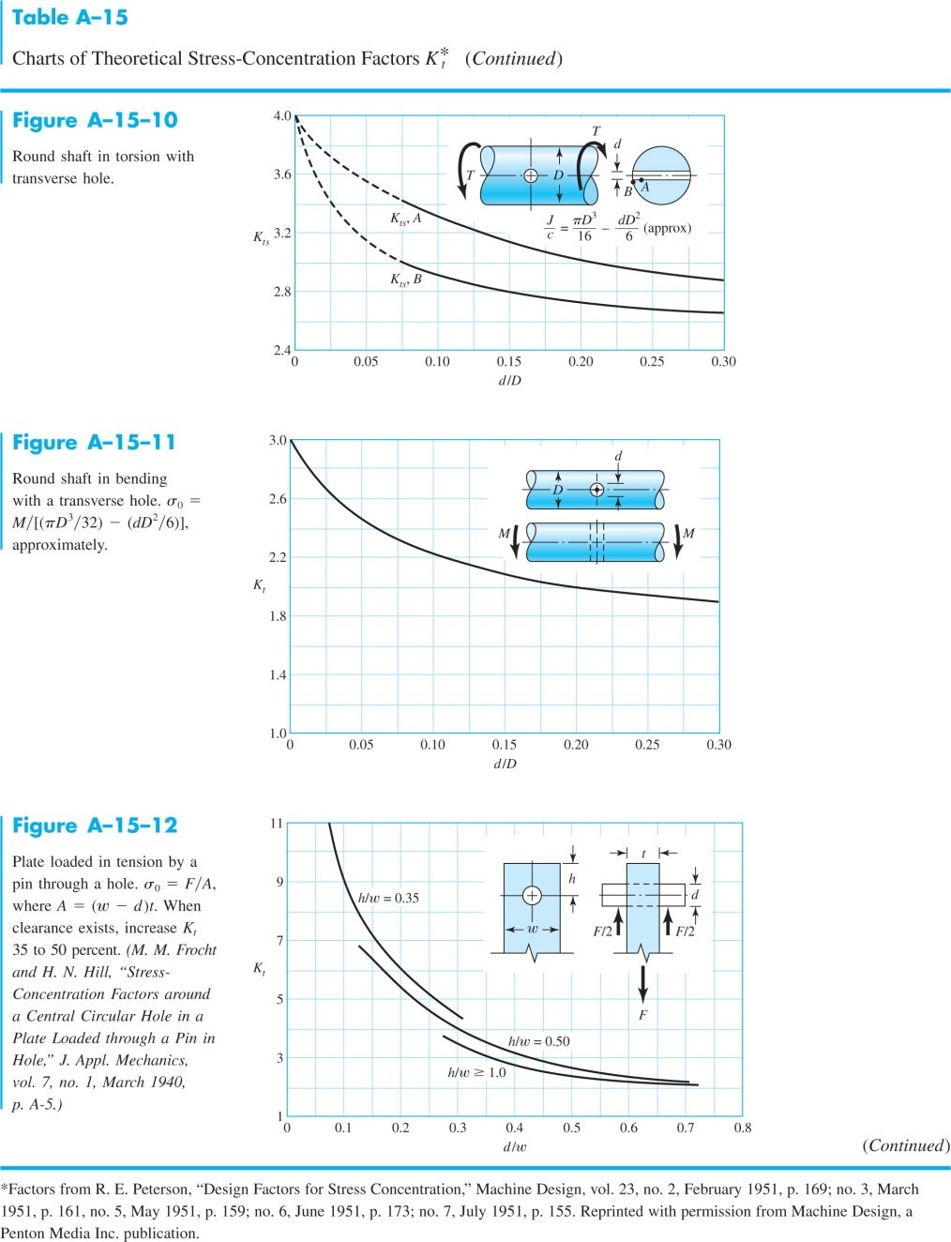

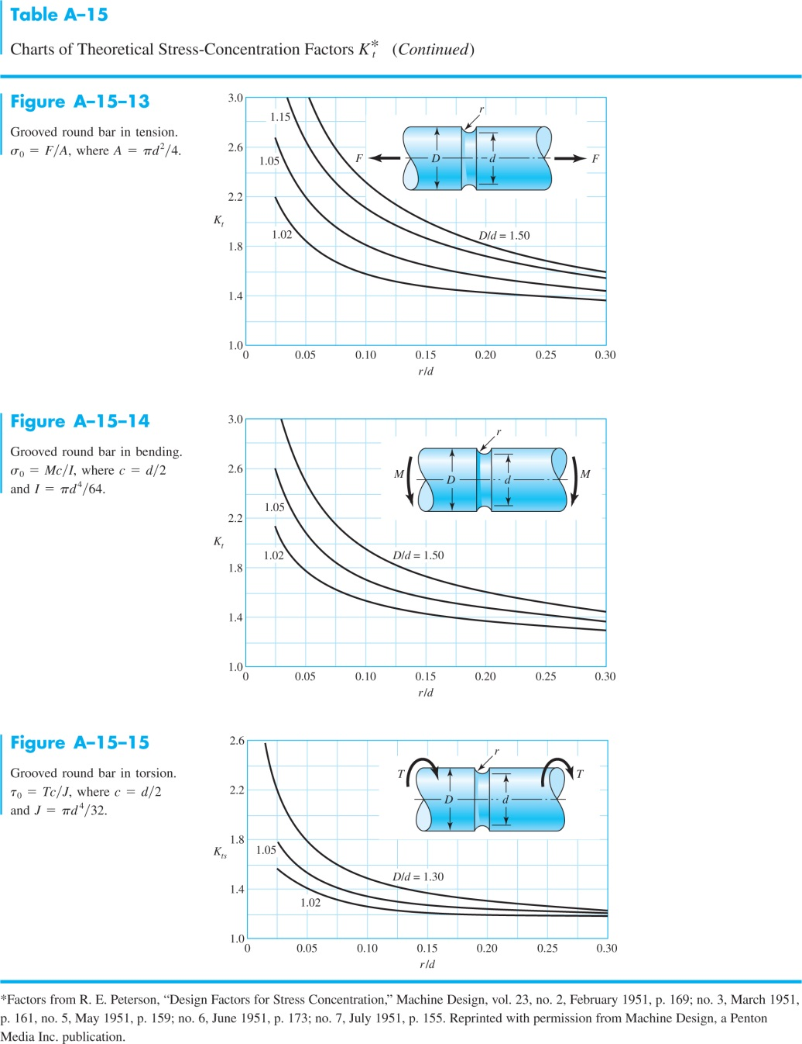

**WELDING (FILLET WELDS)**







**MATERIAL PROPERTIES**

